**OrthoAnalyzer**

**PATIENT**

**CASE**

**• ID:** 2110067134

**• SSN:**

**• Name:** PALLAVI SRIVASTAVA

**• Address:**

**• City:**

**• Country:** INDIA

**• Clinic ID:**

**• ID:** 2110067134

**• Operator:** Dr. Pulkit Lakhani

**• Comment:** Pallavi Srivastava (2110067134)

**• Date:** 11‑10‑2021

**• Scan date:** 11‑10‑2021 17:09:55

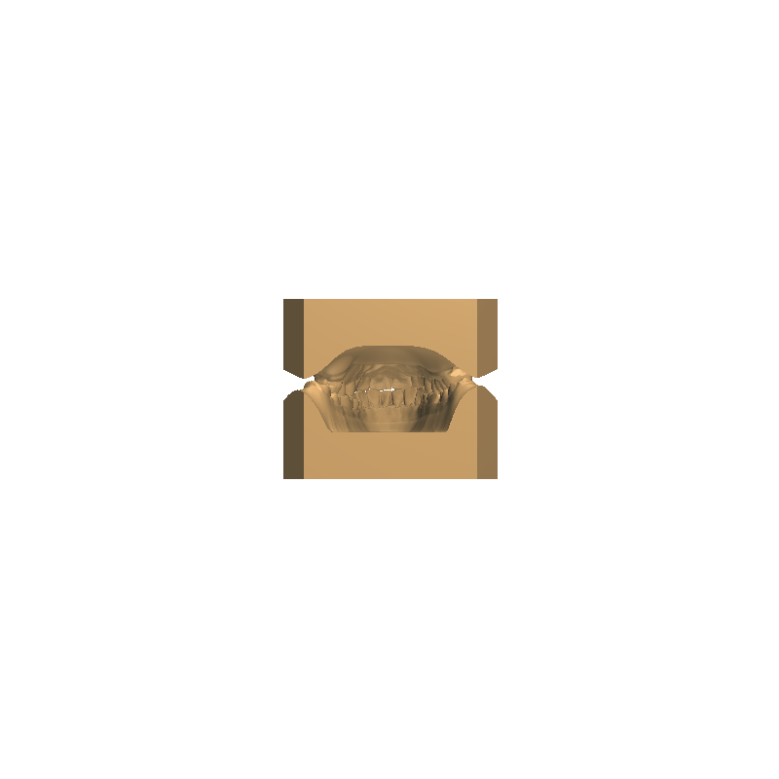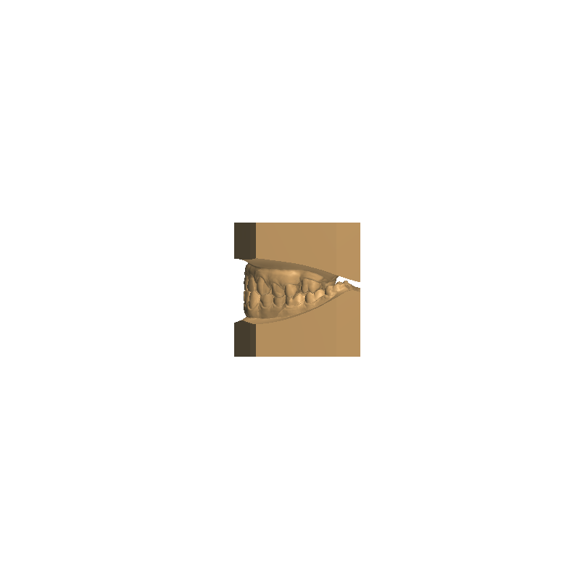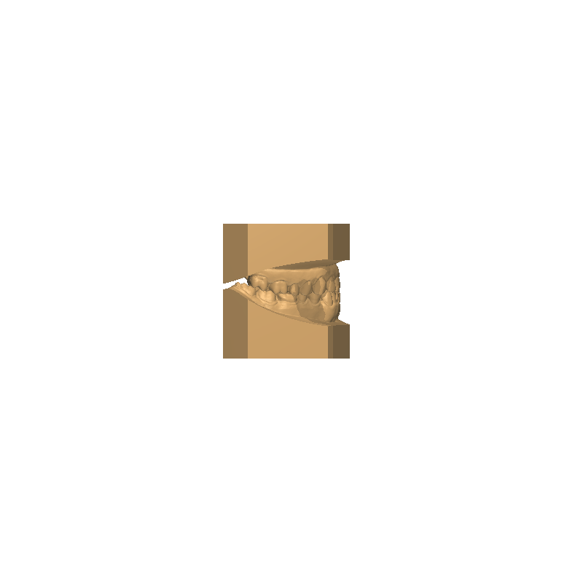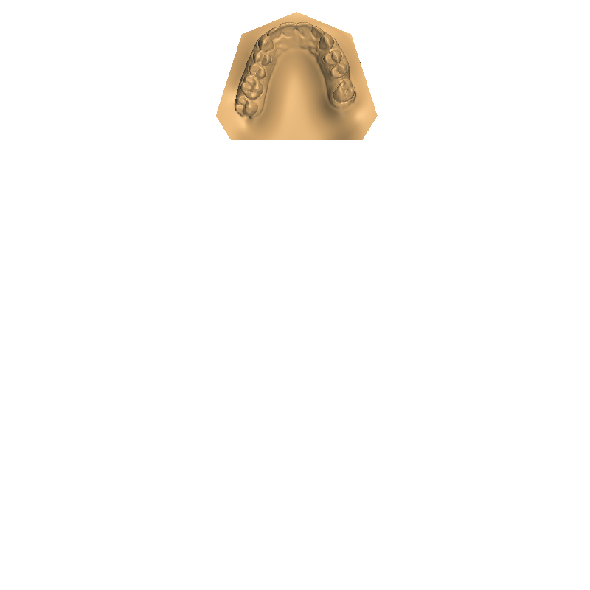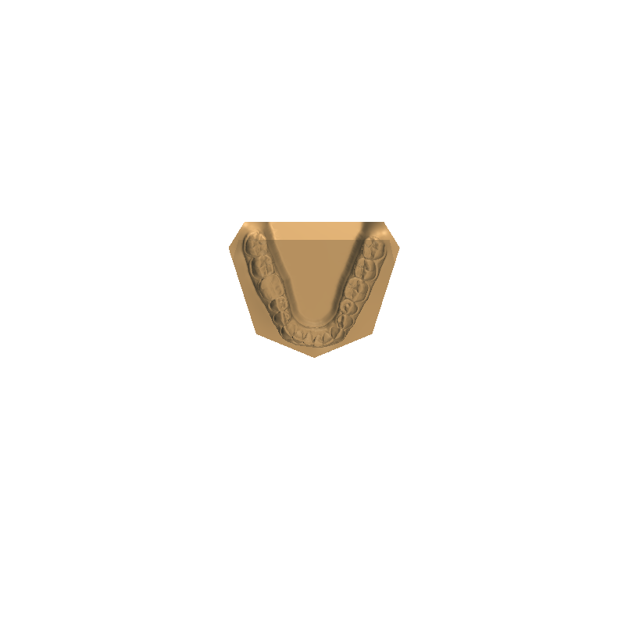Page 1 of 12



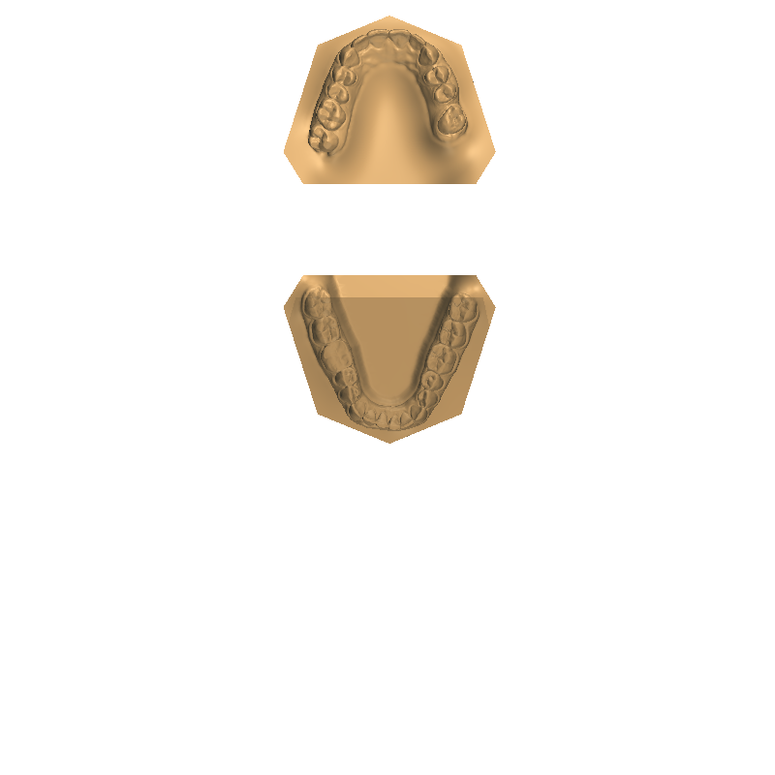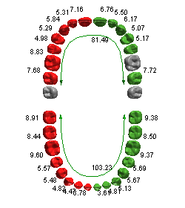**Overview**

**Ideal curve**

0.00

**Ideal length**

0.00

**Bracket offset_length**

**•**

**•**

**Ideal arch analysis**

**OVERALL BOLTON ANALYSIS**

*Ideal ratios*

*Maxillary 6 width:*

*Mandibular 6 width:*

*Ratio:*

**•**

**•**

**•**

**•**

Page 2 of 12



**Default**

Table:

**Tooth width analysis**

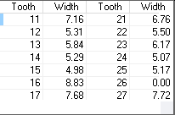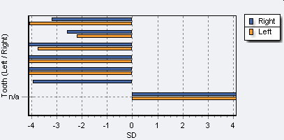**MAXILLARY TOOTH WIDTH ANALYSIS**

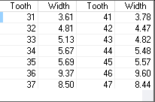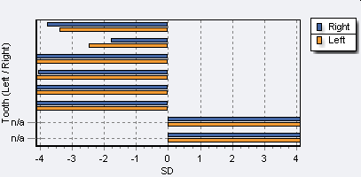**MANDIBULAR TOOTH WIDTH ANALYSIS**

**OVERALL BOLTON ANALYSIS**

*Ideal ratios*

*Maxillary 6 width:*

*Mandibular 6 width:*

*Ratio:*

**•**

**•**

**•**

**•**

Page 3 of 12



**ANTERIOR BOLTON ANALYSIS**

*Maxillary 6 width:*

*Mandibular 6 width:*

*Ratio:*

0.72

26.62

36.75

*Ideal ratios*

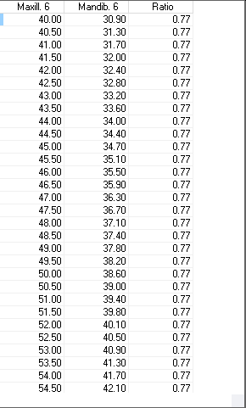**•**

**•**

**•**

**•**

**Bolton analysis**

**OVERALL BOLTON ANALYSIS**

66.09

68.00

1.03

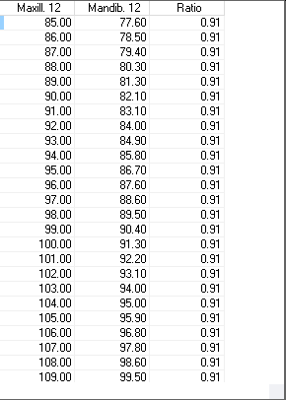*Ideal ratios*

*Maxillary 6 width:*

*Mandibular 6 width:*

*Ratio:*

**•**

**•**

**•**

**•**

Page 4 of 12



**OVERALL BOLTON ANALYSIS**

*Ideal ratios*

*Maxillary 6 width:*

*Mandibular 6 width:*

*Ratio:*

**•**

**•**

**•**

**•**

**Default**

Table:

**Space analysis**

**MAXILLARY SPACE ANALYSIS**

*Total space available:*

24.74

57.26

*Sum of left canine & premolars:*

1.#J

*Sum of right canine & premolars*

*Total space required*

*Discrepancy*

**Moyers**

**Tanaka & Johnston**

1.#J

1.#J

1.#J

19.33

19.33

63.40

‑6.14

**•**

**•**

**•**

**•**

**•**

**•**

*Sum of left canine & premolars:*

*Sum of right canine & premolars*

*Total space required*

*Discrepancy*

**•**

**•**

**•**

**•**

*Sum of incisor widths*

**MANDIBULAR SPACE ANALYSIS**

16.66

49.02

1.#J

1.#J

1.#J

1.#J

18.83

18.83

54.32

‑5.30

*Total space available:*

*Sum of incisor widths*

**•**

**•**

*Sum of left canine & premolars:*

*Sum of right canine & premolars*

*Total space required*

*Discrepancy*

**Moyers**

**•**

**•**

**•**

**•**

**Tanaka & Johnston**

*Sum of left canine & premolars:*

*Sum of right canine & premolars*

*Total space required*

*Discrepancy*

**•**

**•**

**•**

**•**

**Screen snaphots**

**• Date:** 13‑10‑2021 09:33:35

**• Comment:**

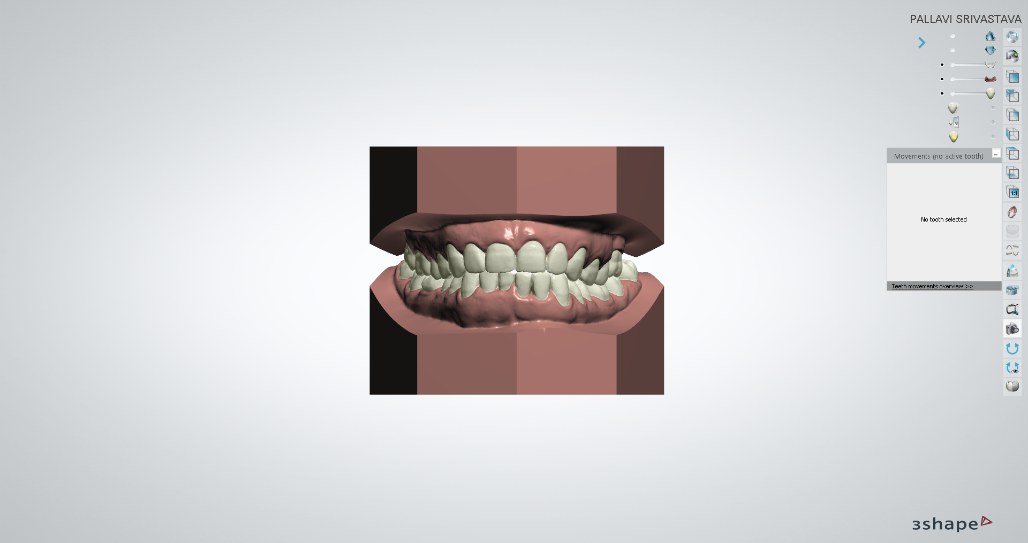**• Date:** 13‑10‑2021 09:33:43

**• Comment:**

Page 5 of 12



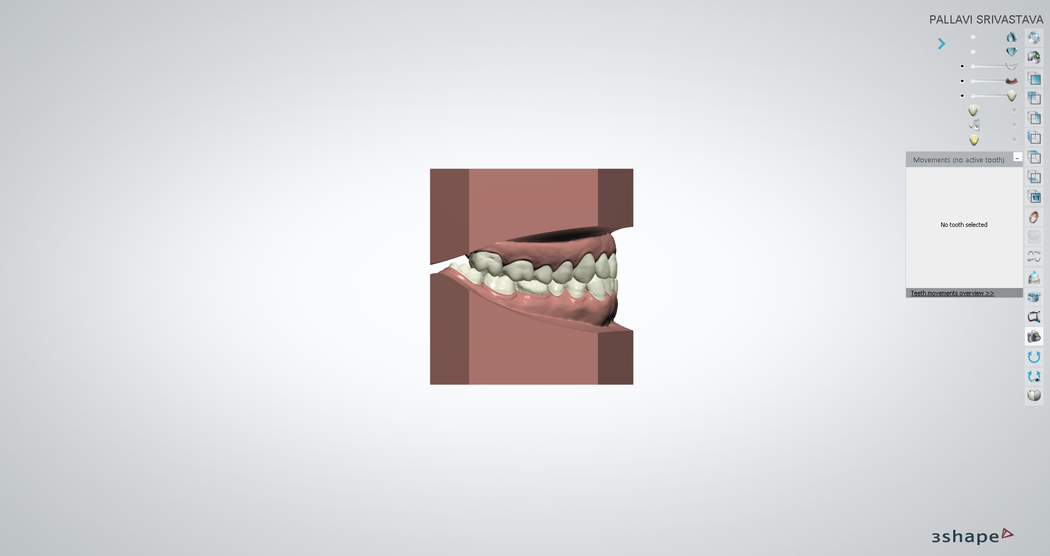**• Date:** 13‑10‑2021 09:33:48

**• Comment:**

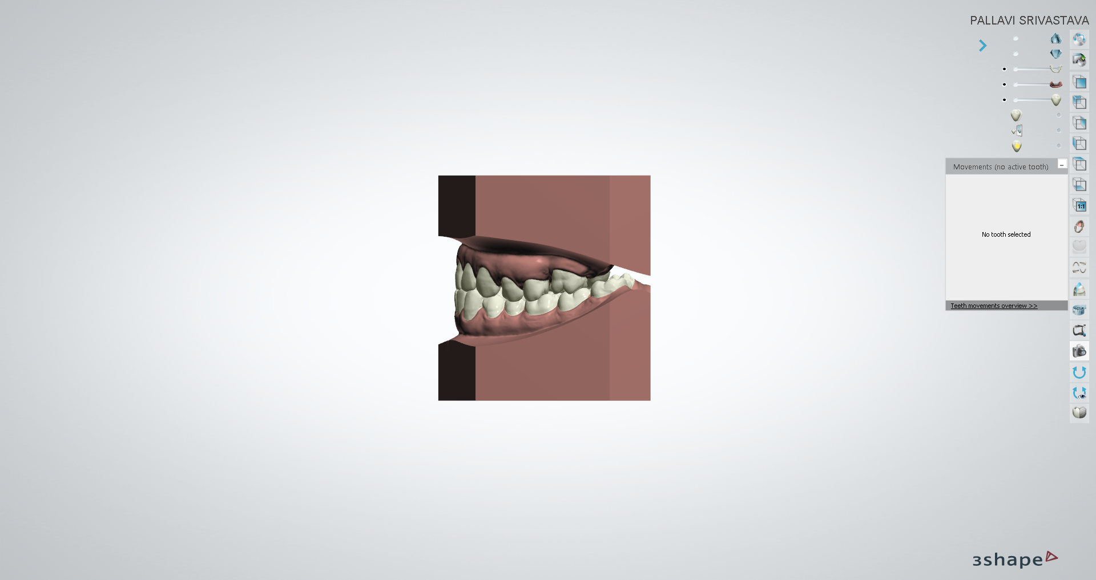**• Date:** 13‑10‑2021 09:33:55

**• Comment:**

Page 6 of 12



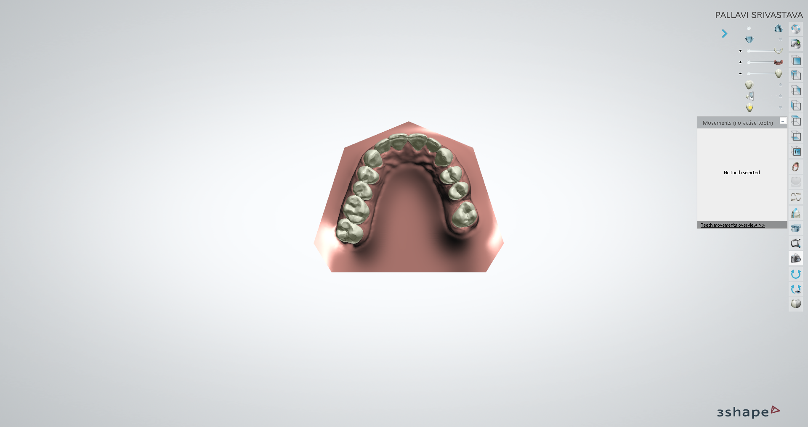**• Date:** 13‑10‑2021 09:34:02

**• Comment:**

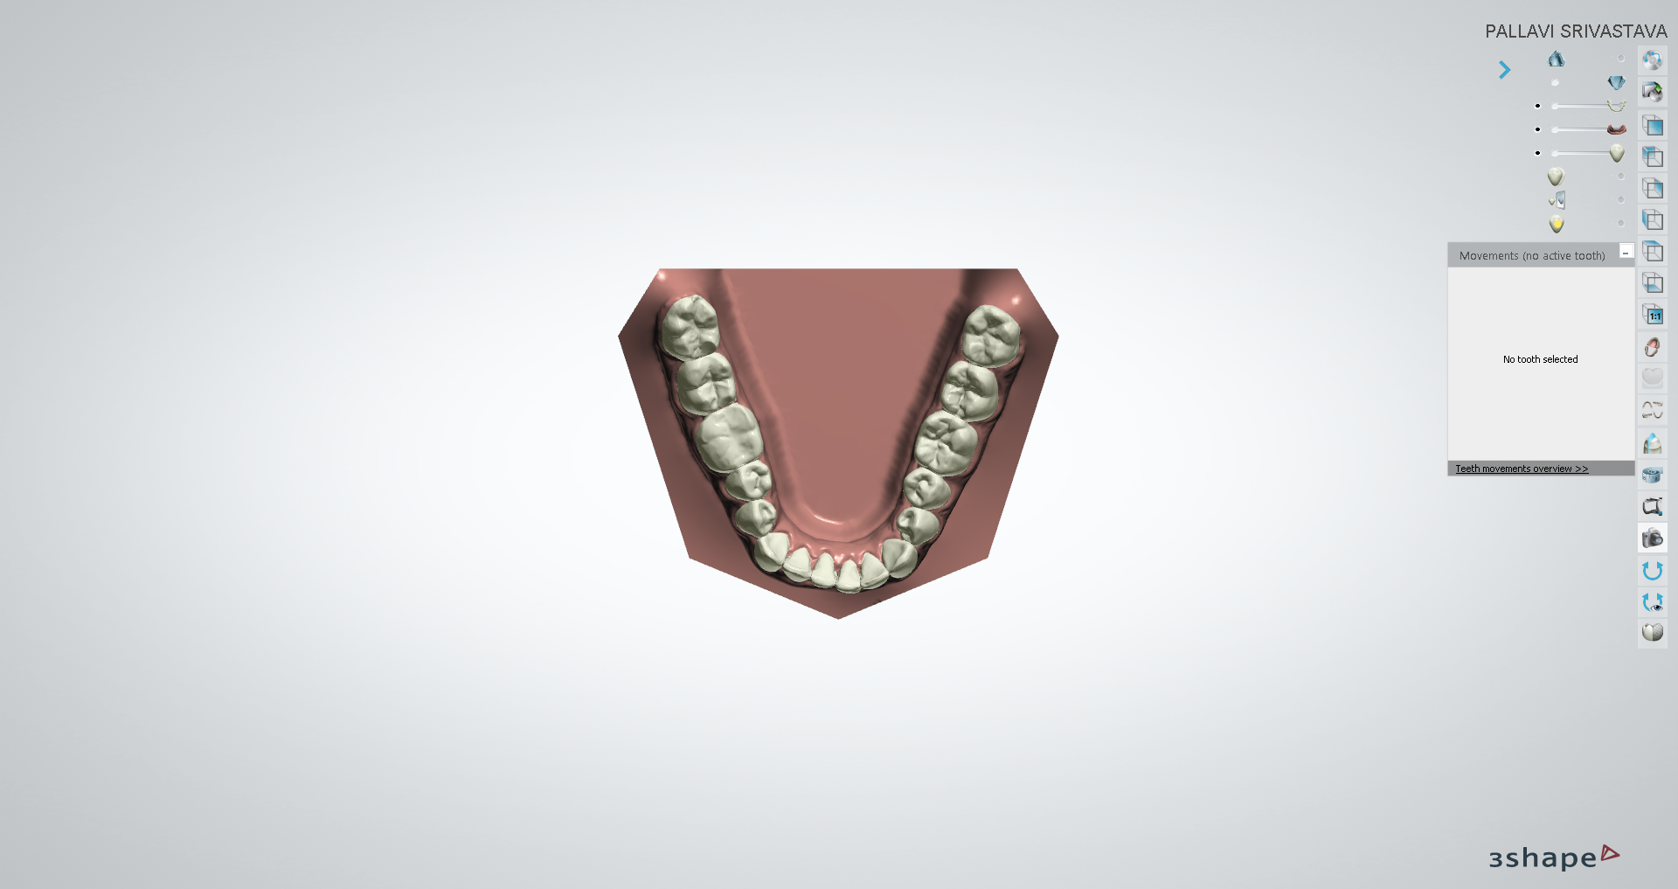**• Date:** 13‑10‑2021 09:34:19

**• Comment:**

Page 7 of 12



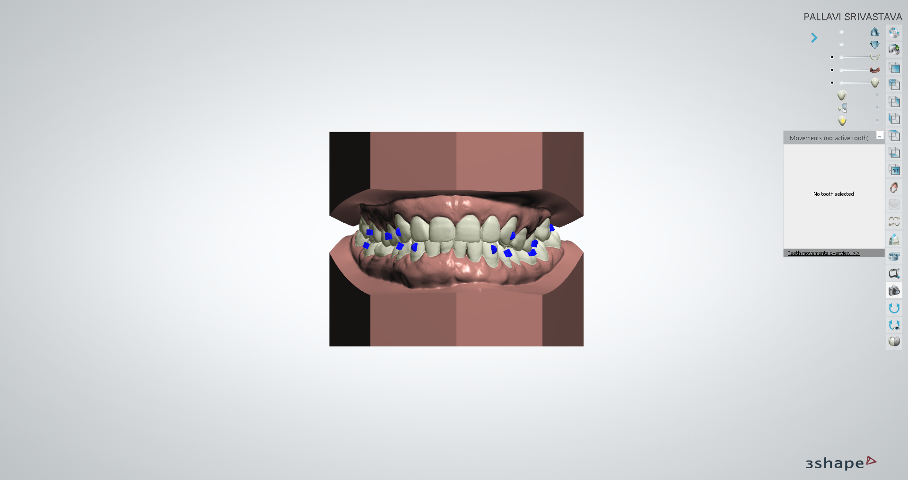**• Date:** 13‑10‑2021 09:34:26

**• Comment:**

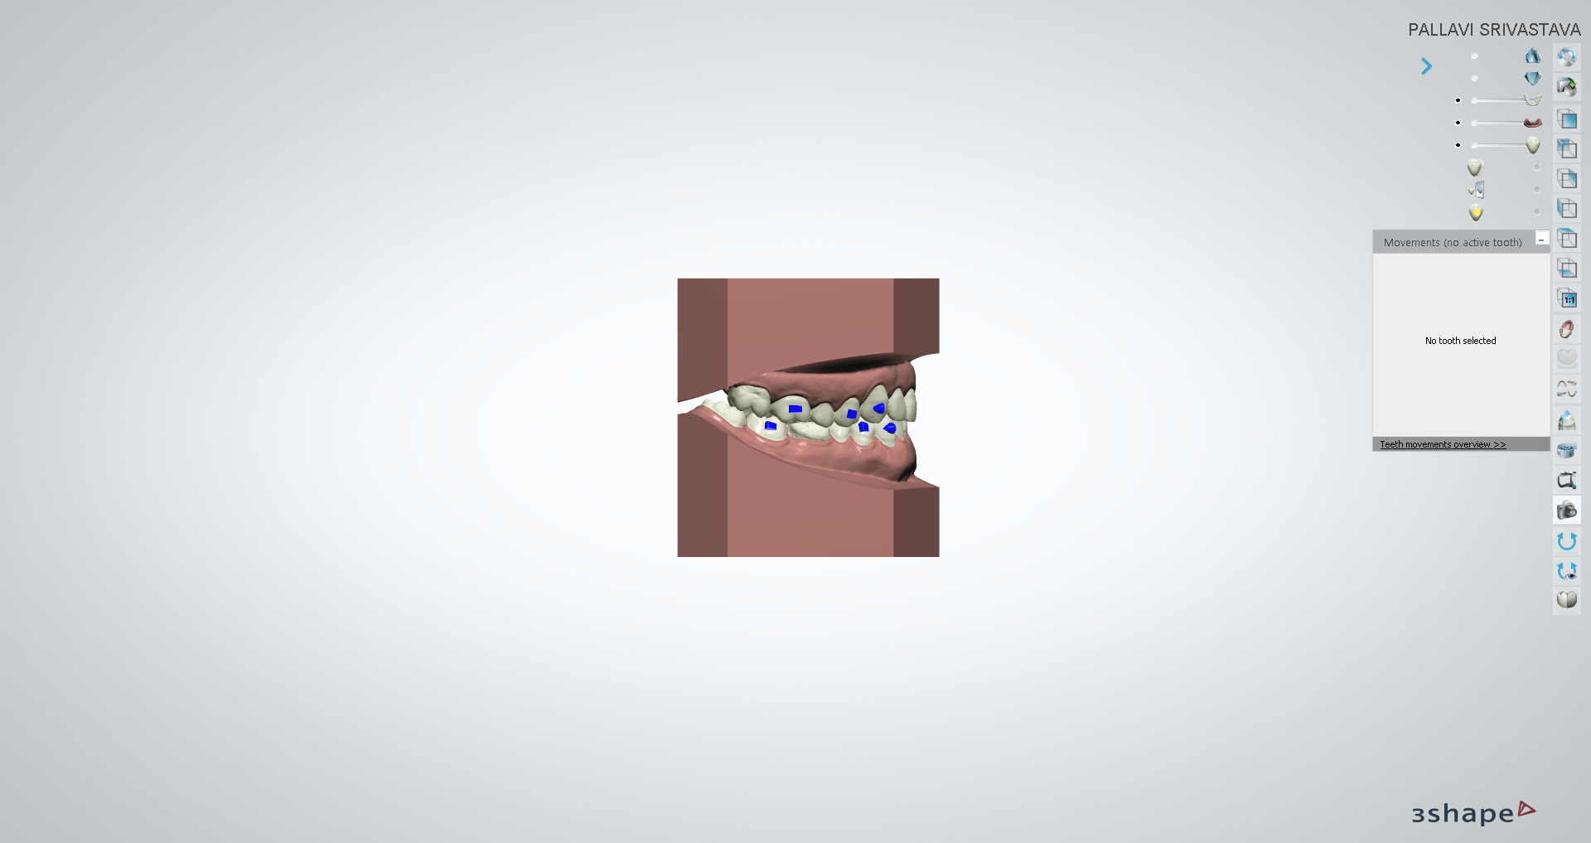**• Date:** 13‑10‑2021 09:34:31

**• Comment:**

Page 8 of 12



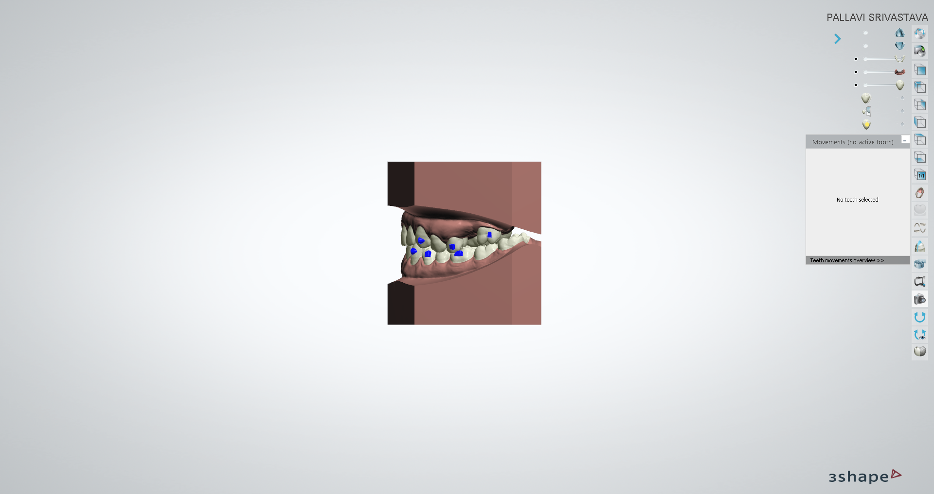**• Date:** 13‑10‑2021 09:34:38

**• Comment:**

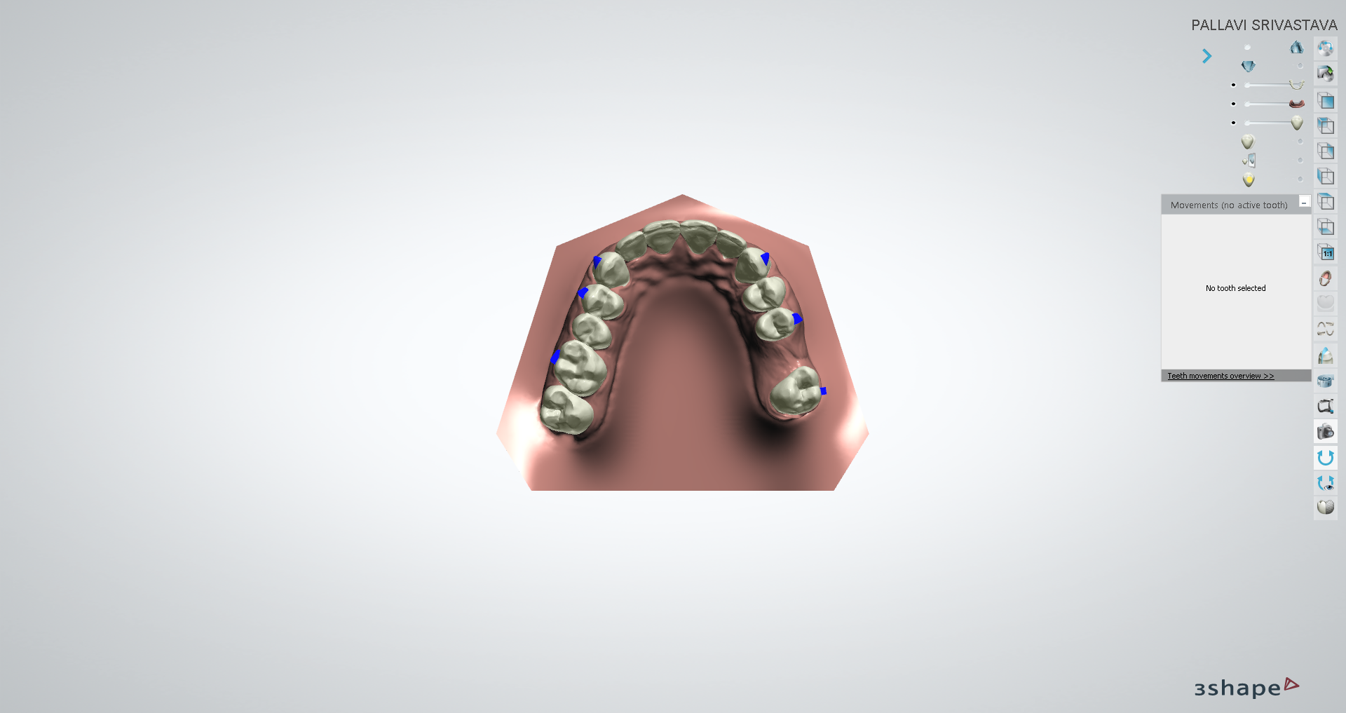**• Date:** 13‑10‑2021 09:34:46

**• Comment:**

Page 9 of 12



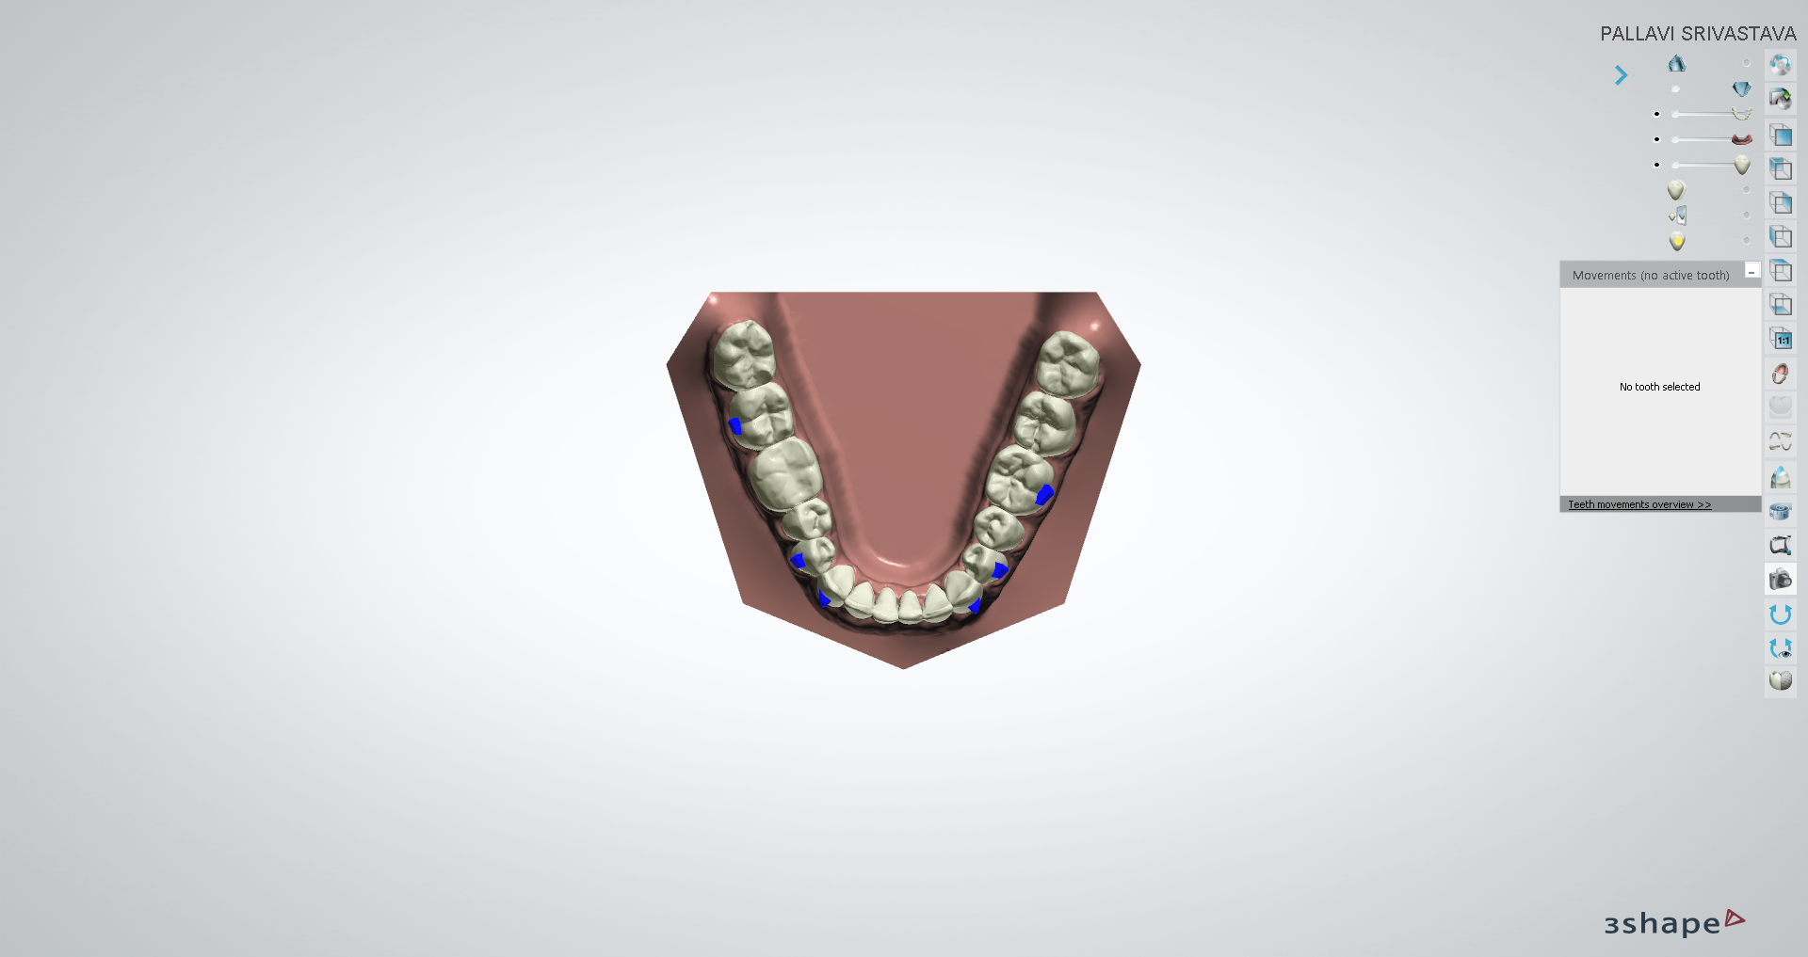**Schwartz Korkhaus Analyses** (Unweighted Total: **0.00,** Weighted Total: **0.00**)

UW: 0.00 W: x1.00 = 0.00

**Korkhaus Schwartz Maxilla**

Korkhaus A

24.74

**•**

Korkhaus B (Line Korkhaus U4_4)

value is undefined

**•**

Korkhaus B Ideal

34.00

**•**

Korkhaus B Discrepancy

value is undefined

**•**

Korkhaus C (Line Korkhaus U6_6)

value is undefined

**•**

Korkhaus C Ideal

43.50

**•**

Korkhaus C Discrepancy

value is undefined

**•**

Korkhaus D (Korkhaus Distance U1_1)

value is undefined

**•**

Korkhaus D Ideal

18.00

**•**

Korkhaus D Discrepancy

value is undefined

**•**

UW: 0.00 W: x1.00 = 0.00

**Korkhaus Schwartz Mandible**

Korkhaus B1 (Korkhaus Line L4_4)

value is undefined

**•**

Korkhaus B1 Ideal

34.00

**•**

Korkhaus B1 Discrepancy

value is undefined

**•**

Korkhaus C1 (Korkhaus Line L6_6)

value is undefined

**•**

Korkhaus C1 Ideal

42.50

**•**

Korkhaus C1 Discrepancy

value is undefined

**•**

Page 10 of 12



**Teeth Movement Report**

**Setup:**

Tooth Number

Rotation

Angulation

Incli‑ nation

Left/

Right

Extrusion/ Intrusion

Forward/ Backward

Long Axis

Circum‑ference

**12‑10‑2021 14:28:30**

IPR Distal (mm)

IPR Mesial (mm)

16

7.3 deg

64.2 deg

33.5 mm

15

5.3 deg

‑0.2 mm

81.1 deg

23.8 mm

14

‑0.2 mm

81.1 deg

24.7 mm

13

‑0.4 mm

0.6 mm

81.1 deg

22.2 mm

12

‑0.2 mm

‑0.6 mm

75.5 deg

18.4 mm

11

2.9 deg

‑0.1 mm

‑0.2 mm

‑0.5 mm

75.5 deg

20.4 mm

21

6.5 deg

‑1.0 deg

0.1 mm

‑0.3 mm

‑0.2 mm

75.5 deg

20.1 mm

22

‑3.1 deg

‑0.2 mm

‑0.5 mm

75.5 deg

17.4 mm

23

‑0.1 mm

0.5 mm

0.3 mm

75.5 deg

21.5 mm

24

1.2 mm

0.2 mm

75.5 deg

25.2 mm

25

14.5 deg

1.5 mm

81.6 deg

24.2 mm

27

11.3 deg

‑6.0 deg

‑1.8 mm

0.8 mm

81.6 deg

31.6 mm

34

‑9.4 deg

‑0.9 mm

‑0.7 mm

83.2 deg

20.5 mm

33

‑8.9 deg

‑0.8 mm

‑0.6 mm

‑1.9 mm

87.2 deg

19.6 mm

32

‑7.9 deg

‑4.0 deg

‑0.3 mm

‑0.5 mm

‑1.7 mm

87.2 deg

15.3 mm

31

6.5 deg

‑7.0 deg

0.8 mm

‑0.9 mm

‑1.6 mm

87.2 deg

13.6 mm

41

‑2.7 deg

‑3.0 deg

‑0.7 mm

‑0.6 mm

‑1.3 mm

77.8 deg

13.0 mm

42

‑0.6 mm

‑1.6 mm

77.8 deg

14.6 mm

43

‑1.0 mm

‑1.7 mm

77.8 deg

19.2 mm

44

‑0.7 mm

69.8 deg

19.8 mm

**Setup:**

Tooth Number

Rotation

Angulation

Incli‑ nation

Left/

Right

Extrusion/ Intrusion

Forward/ Backward

Long Axis

Circum‑ference

**UPLOAD PLAN**

IPR Distal (mm)

IPR Mesial (mm)

16

7.3 deg

64.2 deg

33.5 mm

15

5.3 deg

‑0.2 mm

81.1 deg

23.8 mm

14

‑0.4 mm

81.1 deg

24.7 mm

13

‑0.6 mm

0.6 mm

0.1 mm

81.1 deg

22.2 mm

12

‑0.4 mm

‑0.6 mm

75.5 deg

18.4 mm

11

2.9 deg

‑0.2 mm

‑0.2 mm

‑0.6 mm

75.5 deg

20.4 mm

21

6.5 deg

‑1.0 deg

0.2 mm

‑0.3 mm

‑0.3 mm

75.5 deg

20.1 mm

22

‑7.1 deg

‑0.3 mm

‑0.6 mm

75.5 deg

17.4 mm

23

‑0.1 mm

0.8 mm

0.3 mm

75.5 deg

21.5 mm

24

1.2 mm

0.2 mm

75.5 deg

25.2 mm

25

14.5 deg

1.5 mm

81.6 deg

24.2 mm

27

11.3 deg

‑6.0 deg

‑1.8 mm

0.8 mm

81.6 deg

31.6 mm

35

81.8 deg

23.9 mm

Manual

Manual

34

‑9.4 deg

‑0.9 mm

‑0.7 mm

83.2 deg

20.5 mm

Manual

Manual

33

‑8.9 deg

‑0.8 mm

‑0.6 mm

‑1.9 mm

87.2 deg

19.6 mm

Manual

Manual

32

‑7.9 deg

‑4.0 deg

‑0.3 mm

‑0.5 mm

‑1.6 mm

87.2 deg

15.3 mm

Manual

Manual

31

6.5 deg

‑7.0 deg

0.8 mm

‑0.9 mm

‑1.6 mm

87.2 deg

13.6 mm

Manual

Manual

41

‑2.7 deg

‑3.0 deg

‑0.7 mm

‑0.6 mm

‑1.3 mm

77.8 deg

13.0 mm

Manual

Manual

42

‑0.6 mm

‑1.6 mm

77.8 deg

14.6 mm

Manual

Manual

43

‑1.0 mm

‑1.7 mm

77.8 deg

19.2 mm

Manual

Manual

Page 11 of 12



44

‑0.8 mm

69.8 deg

19.8 mm

Manual

Manual

45

69.8 deg

22.6 mm

Manual

Manual

Page 12 of 12

